Virtual Pet



In this project you will make a virtual pet.

You’ll need to feed it to stop it getting too hungry, give it drinks to stop it getting too thirsty, and show it love to stop it getting too sad.

You’ll do that by showing it actions through your webcam. But first, you’ll need to train your virtual pet to recognise those actions, using machine learning.

The virtual pet artwork in this project was drawn by Grace Lane.



This project worksheet is licensed under a Creative Commons Attribution Non-Commercial Share-Alike License

http://creativecommons.org/licenses/by-nc-sa/4.0/

1. Go to <https://machinelearningforkids.co.uk/> in a web browser
2. Click on “**Get started**”
3. Click on “**Log In**” and type in your username and password  
   *If you can’t remember your password, ask your teacher to reset it for you.*
4. Click on “**Projects**” on the top menu bar
5. Click the **“+ Add a new project**” button.
6. Name your project “virtual pet” and set it to learn how to recognise “**images**”. Click the “**Create**” button  
   
7. You should see “**virtual pet**” in the list of your projects. Click on it.  
   
8. Click the “**Train**” button
9. Click “**+ Add new label**”  
   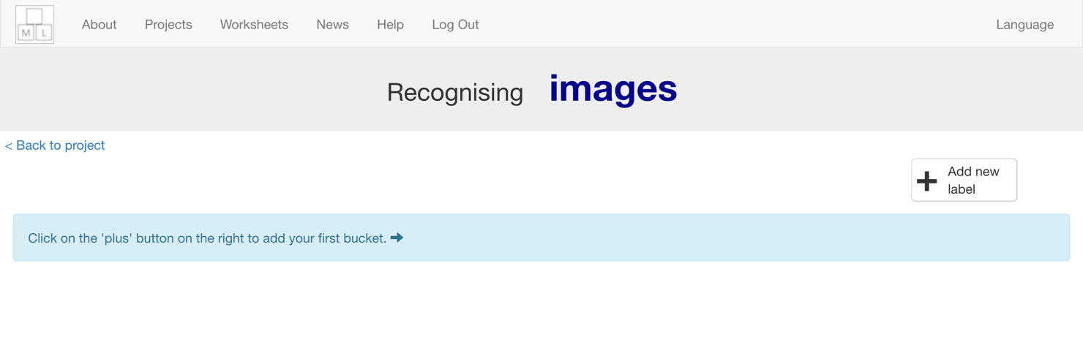
10. Type in “eat”, and press “**Add**”  
    *This is where you’ll collect examples of pictures of food for your virtual pet*
11. Click “**+ Add new label**” again, type in “drink”, and press “**Add**”  
    *This is where you’ll collect examples of photos of drink for your virtual pet*  
    
12. Click “**+ Add new label**” again, type in “love”, and press “**Add**”  
    *This is where you’ll collect examples of pictures of showing love to your virtual pet.*
13. Click the “**webcam**” button in the “**eat**” bucket  
    
14. Find something for your virtual pet to eat and hold it to the webcam  
    Click “**Add**”  
    
15. Click the “**webcam**” button in the “**drink**” bucket
16. Find something for your virtual pet to drink and take a photo of it.  
    
17. Click on the “**webcam**” button in the “**love**” bucket
18. Make a sign that shows love for your virtual pet, and take a photo  
    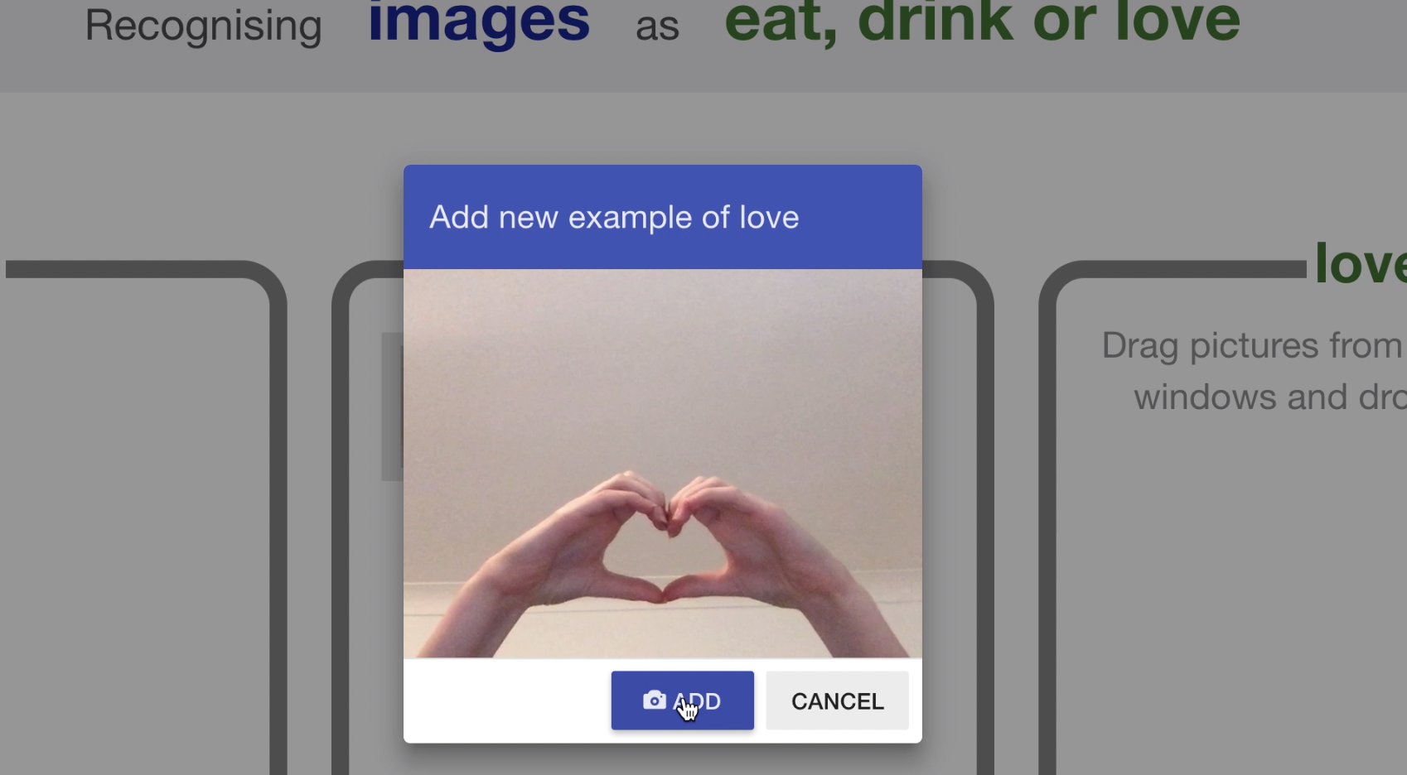
19. Repeat until you have **ten examples** of each action  
    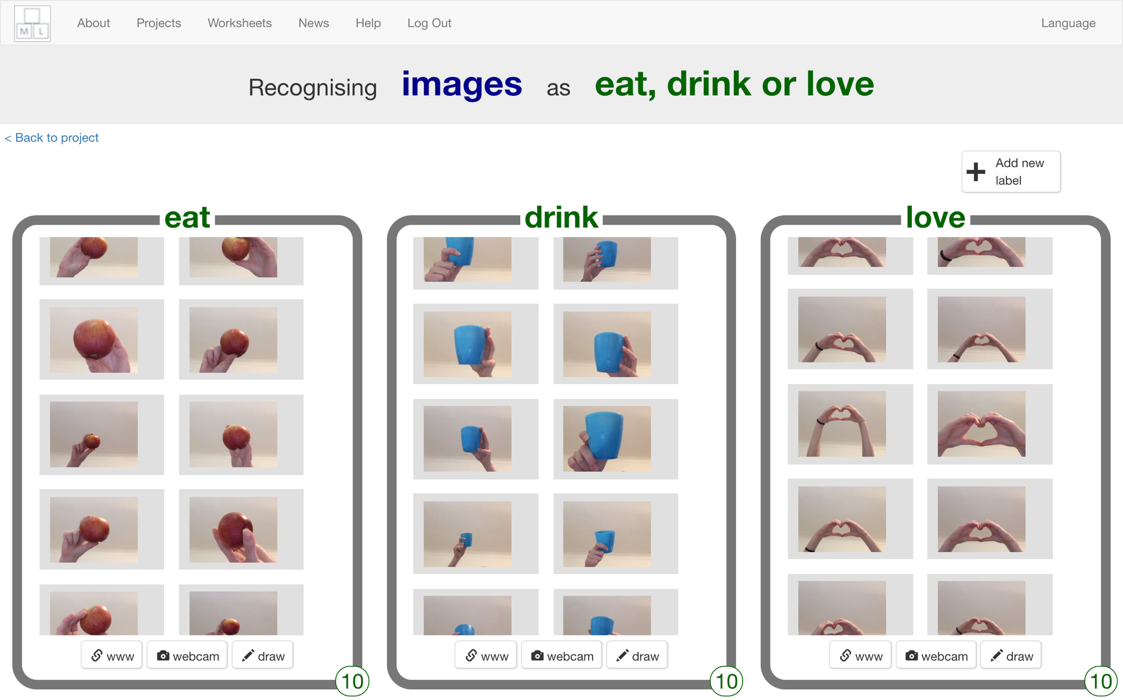
20. Click the “**< Back to project**” link
21. Click the “**Learn & Test**” button  
    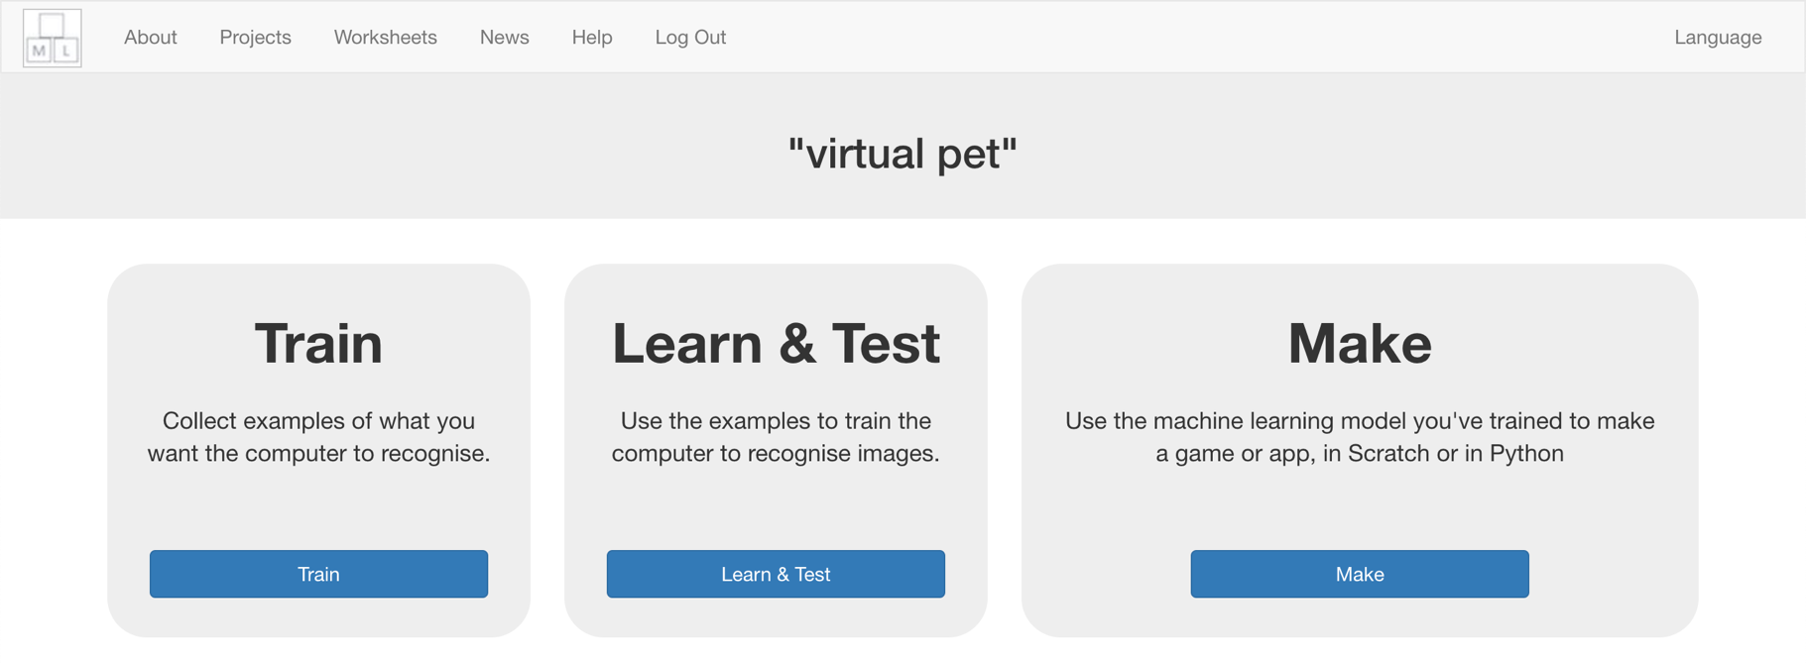
22. Click the “**Train new machine learning model**” button  
    *It might take a few minutes for the computer to train*  
    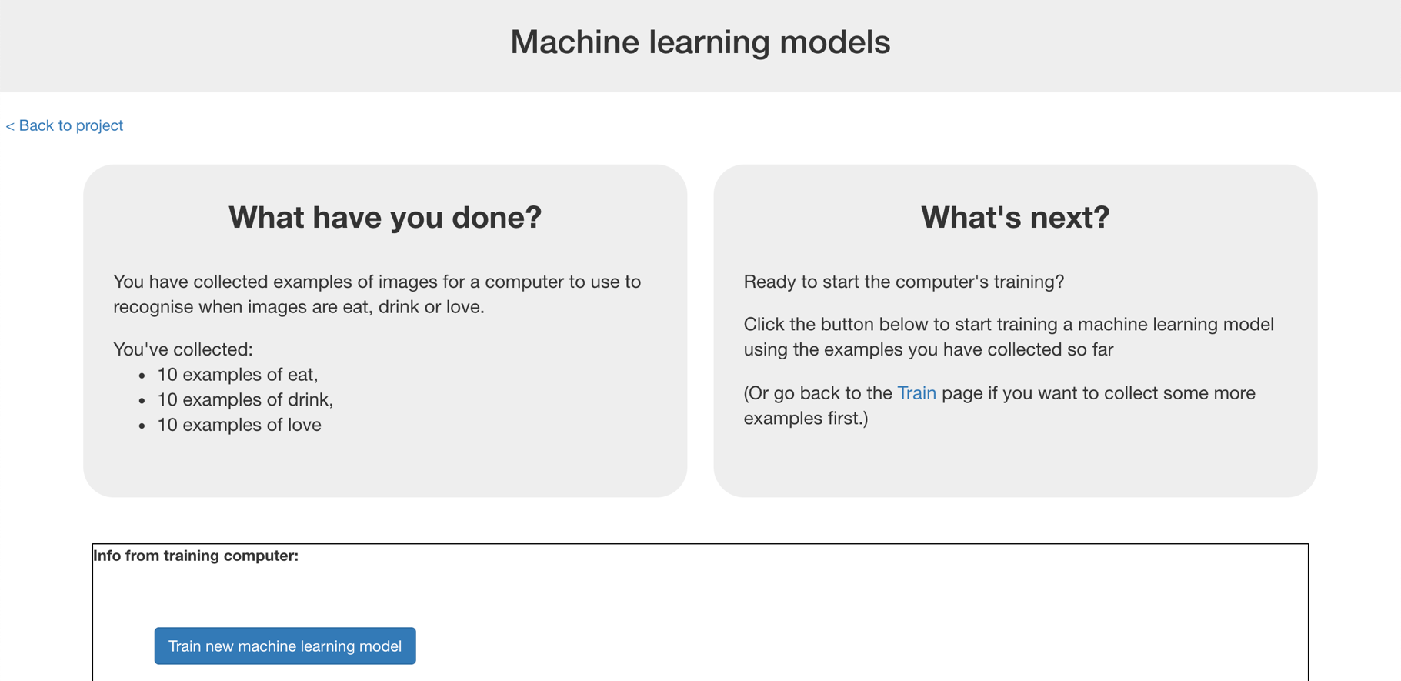
23. Click the “**< Back to project**” link
24. Click the “**Make**” button
25. Click the “**Scratch 3**” button  
    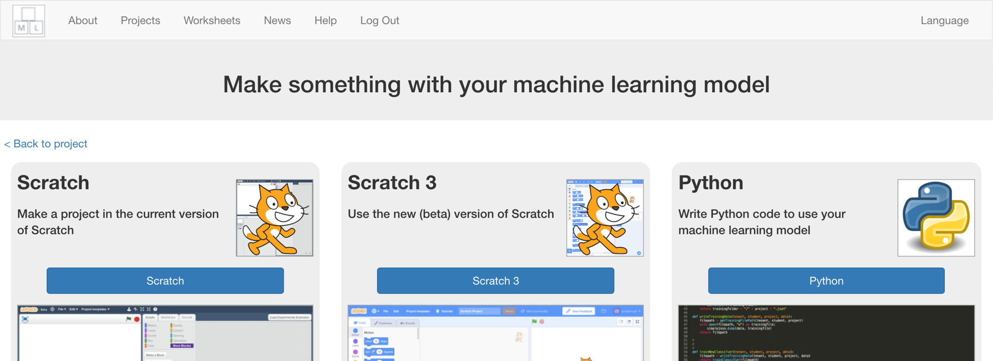
26. Click the “**Open in Scratch 3**” button  
    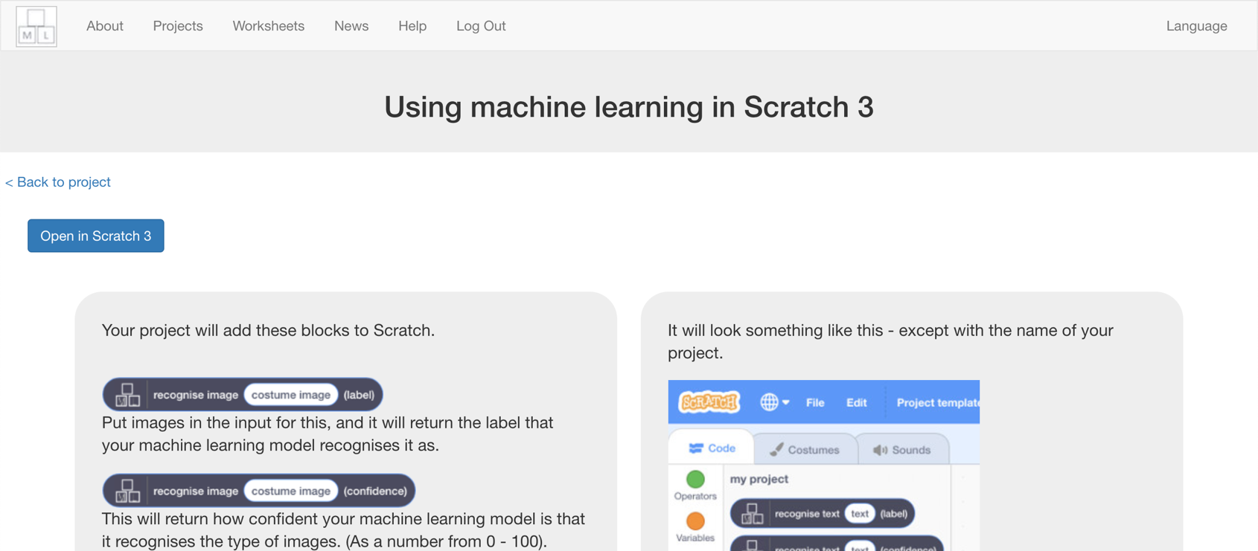
27. Click the “**Train new machine learning model**” button  
    *It might take a few minutes for the model to train.*

**What have you done so far?**

You’ve started to train a computer to recognise whether photos of a face and photos of a covered face. You are doing it by taking example photos. These examples are being used to train a machine learning “model”.

This is called “supervised learning” because of the way you are supervising the computer’s training.

The computer will learn from patterns in the shapes and colours in each of the photos you’ve given it. These will be used to recognise new photos.

1. Click “**< Back to project**”
2. Click the “**Make**” button
3. Click “**Scratch 3**”  
   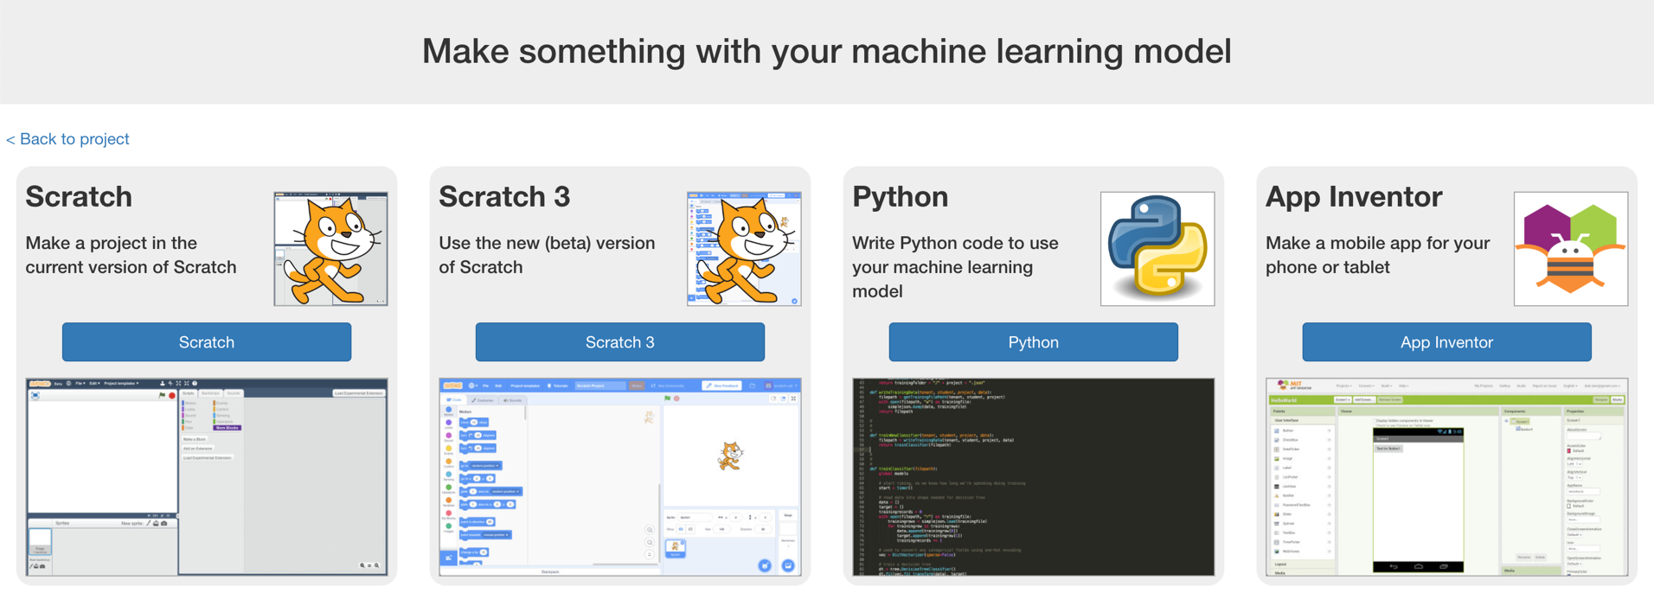
4. Click on “**Open in Scratch 3**”  
   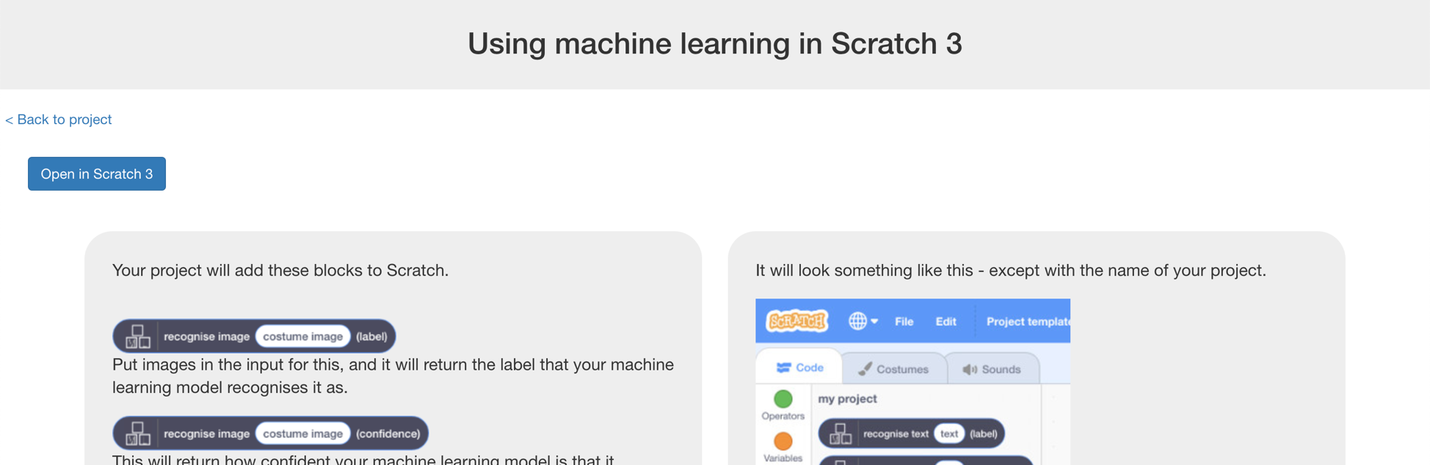
5. Click on “**Try it!**”  
   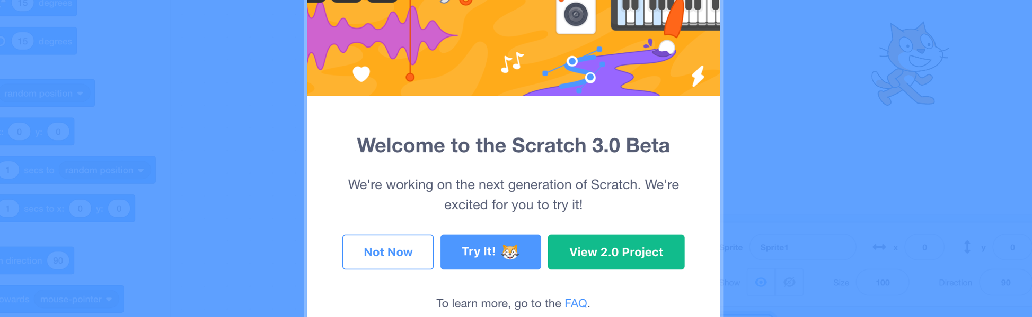
6. Click on “**Project templates**”  
   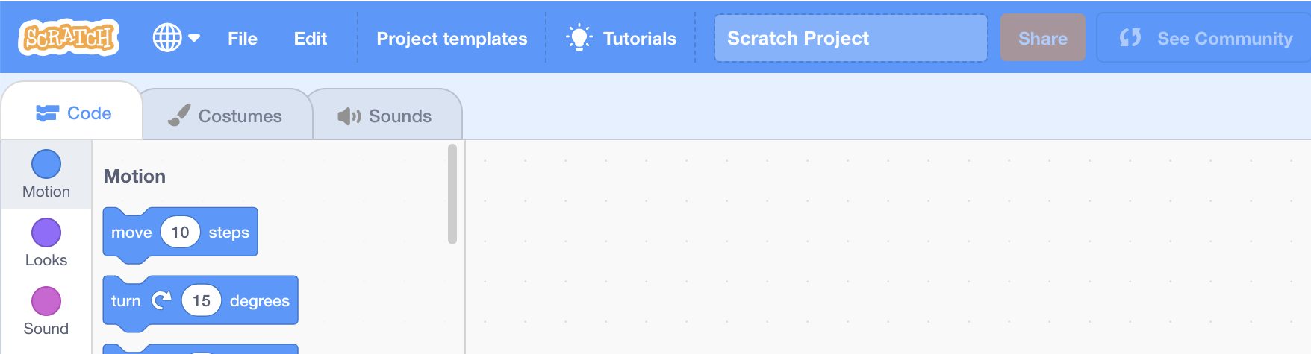
7. Click on the “**Virtual Pet**” template  
   *You might need to scroll down to it  
   If your browser asks for permission to use the web-cam, click* ***Allow***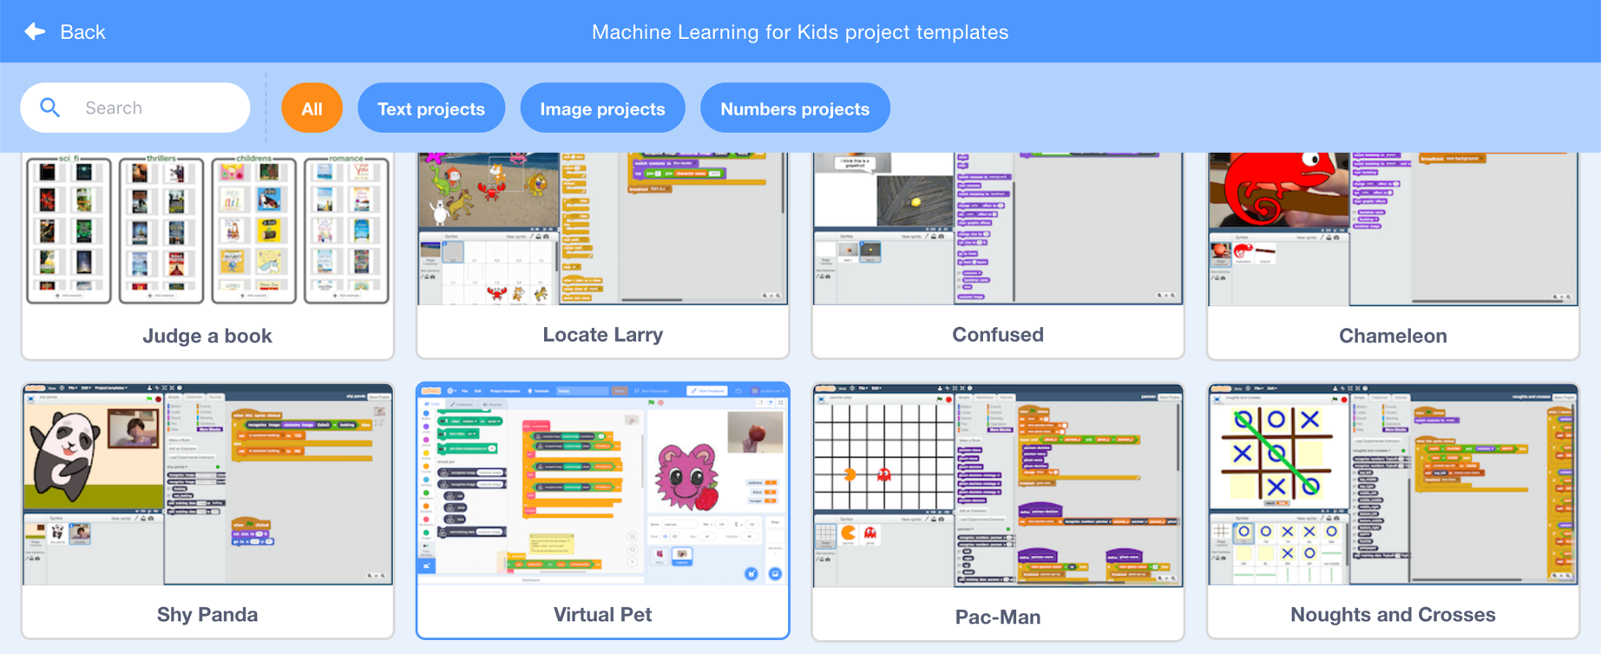
8. The project template has a virtual pet called “Flobzy”.  
   *It has three variables shown on the stage. They will keep increasing over time, and if they get too high, it’ll be game over.  
   “hunger” will go down if you give it food  
   “thirst” will go down if you give it a drink  
   “sadness” will go down if you show it love  
   You’ll do that by taking photos with the webcam.*  
   *But first, you’ll need to add your machine learning model to the project so it can recognise the photos.*   
   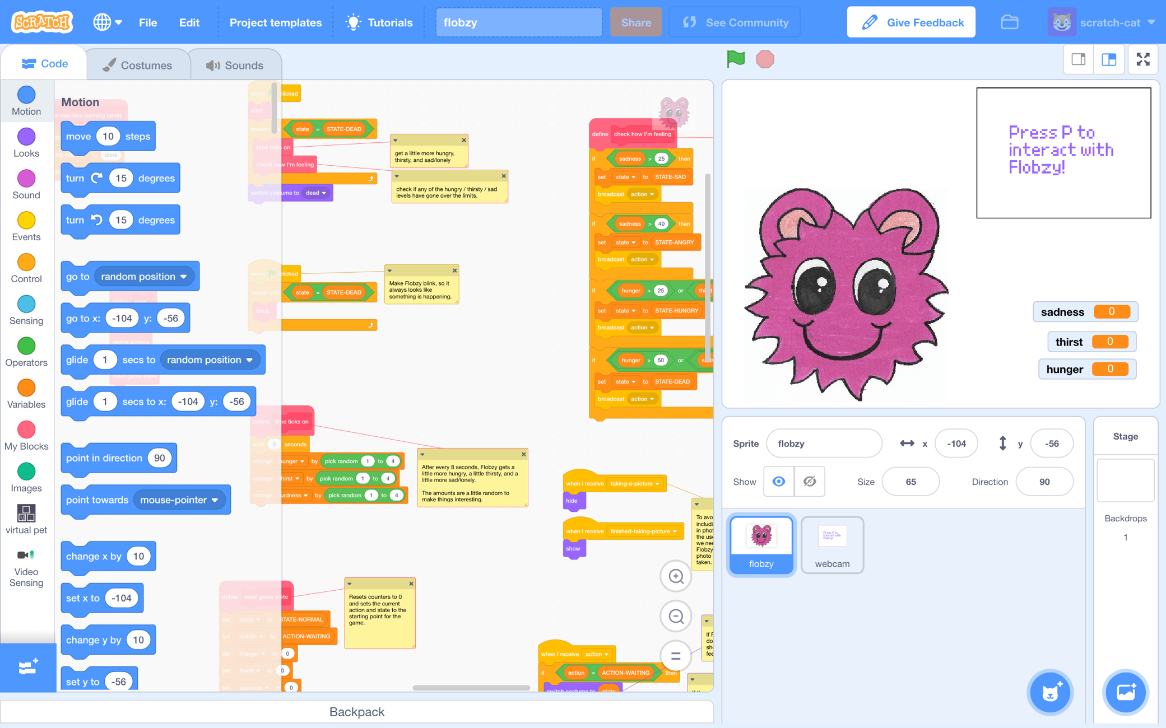
9. Find the “**define machine learning labels**” script  
   *Scroll around to find it. It’s at the* ***top left*** *of the flobzy scripts.  
   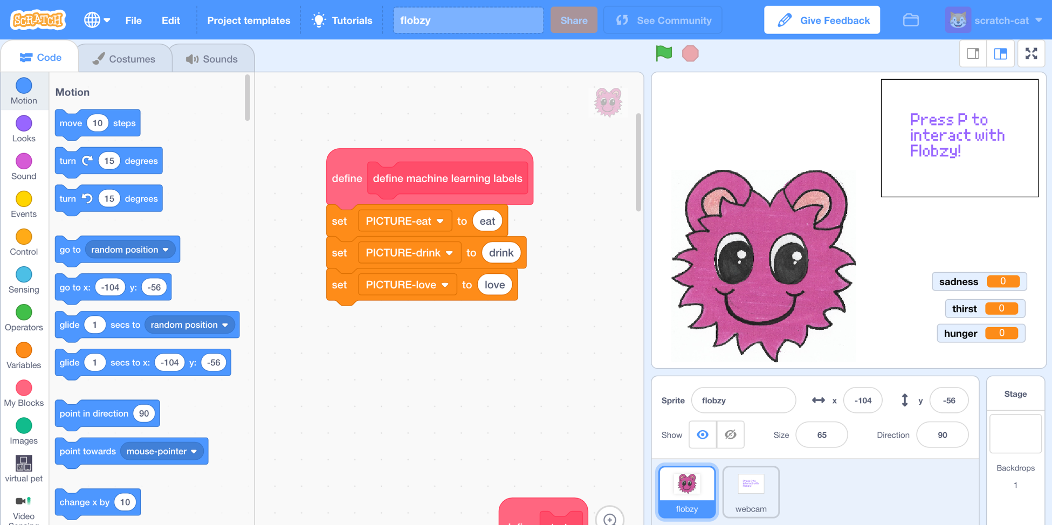*
10. Click on “virtual pet” on the left to find the blocks for your project.  
    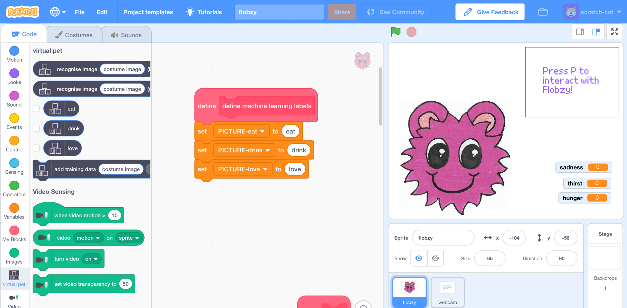
11. Drag the names of your three training buckets into the script  
    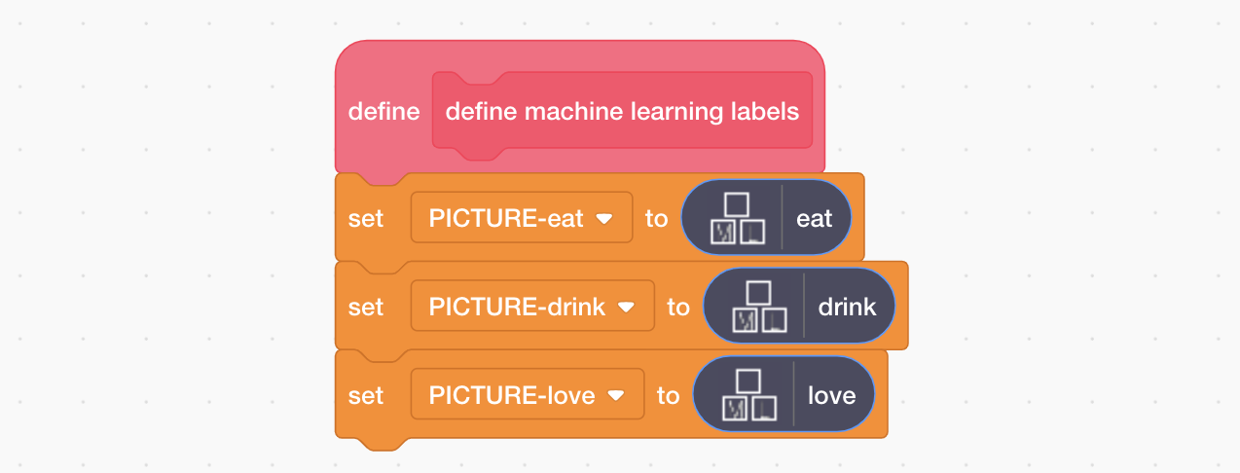
12. Click on the “**webcam**” sprite, and find the “**recognise photo**” script  
    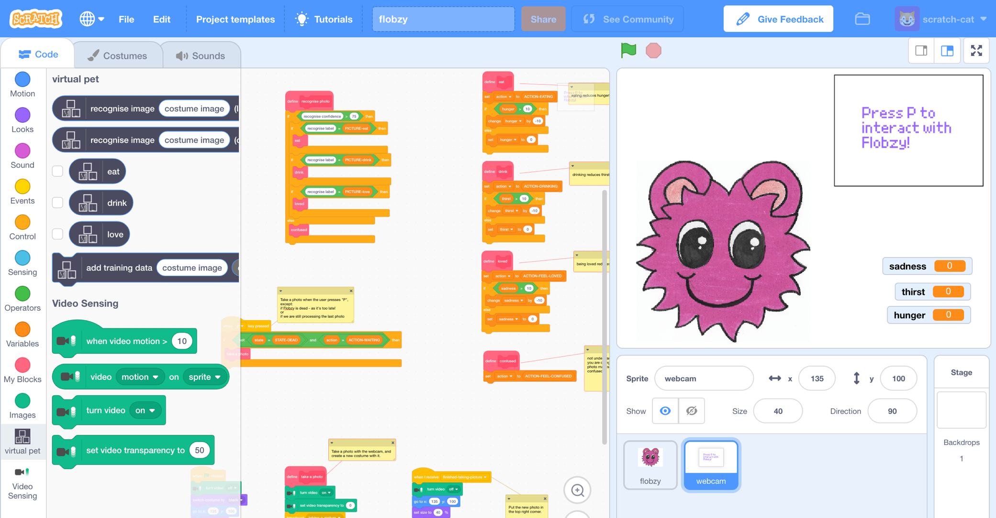
13. Modify the “**recognise photo**” script using blocks from your project  
    *Notice that the first one is using the confidence score (how sure your machine learning model is), and the next three are using the label (what your machine learning model thinks it recognised).*  
    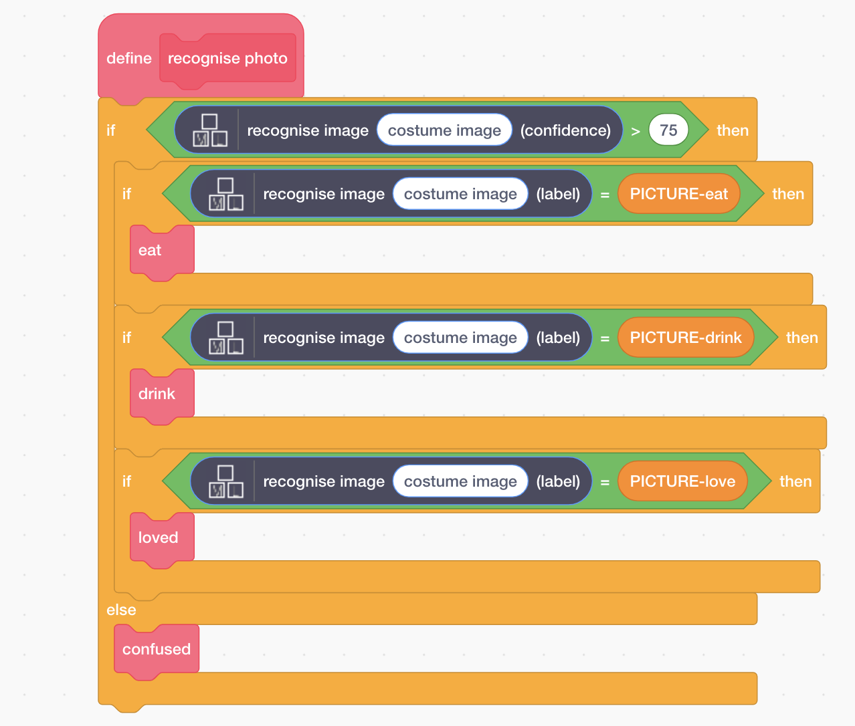
14. Click on “**images**” to find the “**costume image**” block. Drag it into each of the spaces in the script labelled “costume image”.   
    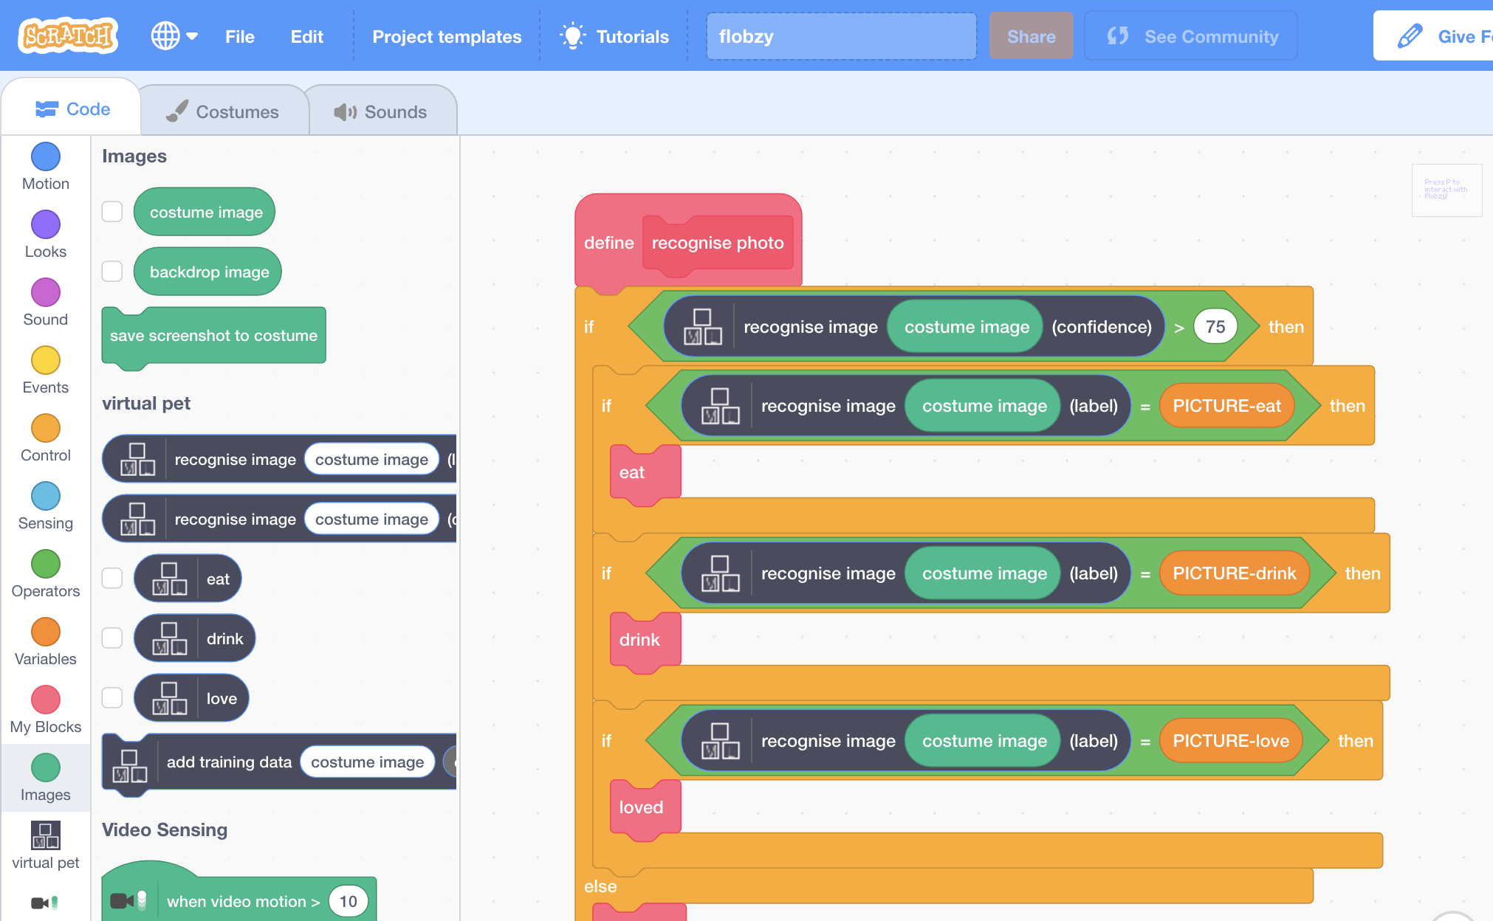
15. Click the full-screen button  
    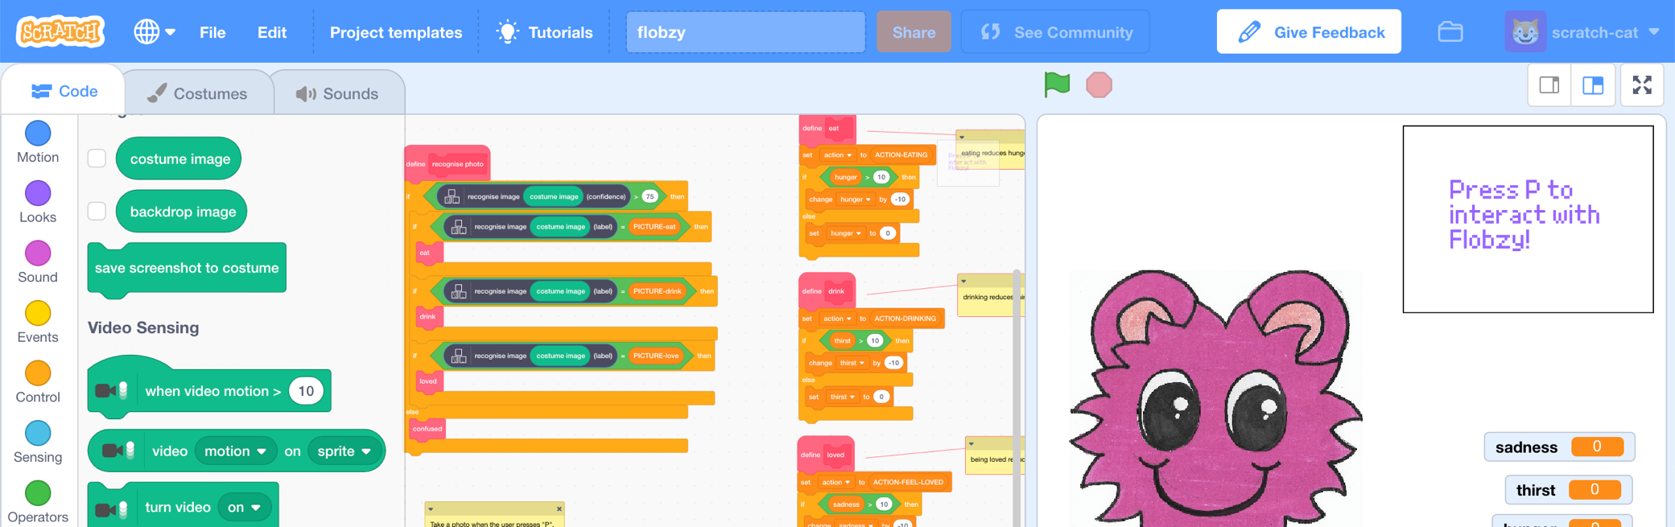
16. Click on the Green Flag to start the game  
    *The sadness, thirst, and hunger values will start to increase.   
    You need to look after your virtual pet to keep it happy and fed.   
      
    You’ll do that by* ***pressing the P button on the keyboard*** *to take a photo.  
    Your virtual pet will use the machine learning model you trained to recognise what you’re doing.*
17. If it recognises a photo of food, you’ll see your virtual pet eat and its hunger value will decrease  
    
18. If it recognises a photo of drink, you’ll see your virtual pet drink and its thirst will decrease  
    
19. If it doesn’t recognise your photo, it’ll look confused  
    *If this happens when you’re showing it photos of food, drink or love, you could try decreasing the confidence number in your script a little.*   
    
20. If the values get too high, it’ll be game over  
    
21. Save your project  
    *Click the* ***full-screen*** *button again   
    Click “****File****” -> “****Save to your computer****”*

**What have you done?**

You’ve created a virtual pet in Scratch that uses machine learning to recognise the actions that you take to look after it.

The machine learning model that you’ve trained is an image classifier, that is able to classify photos based on the training examples you took.

The more examples you give it, the better it should get at recognising your actions.

**Ideas and Extensions**

Now that you’ve finished, why not give one of these ideas a try?

Or come up with one of your own?

**Draw your own pet**

You don’t have to use the pet in the project template. Why not draw your own character? You’ll need costumes for each of the states that the virtual pet can be in.

**Improving your training**

Try testing it with your classmates. Does your pet understand their photos as well?

How can you improve the training so that your pet does the right thing for these sorts of cases?

**Change your pet’s behaviour**

The Scratch script for your pet is complicated, but there are a lot of comments in there to explain how it works.

Think of something that you’d like to change about how your pet behaves, and try changing the script to make it happen.

Try starting with something small, like changing the reward you get for giving your pet something to eat.